# Week 7: Non-AI Approaches in Applications

## Chapter 1 - Rule-based Systems: A Deep Dive into Expert Systems

In the vast landscape of artificial intelligence, rule-based systems, often synonymous with expert systems, represent a paradigm where knowledge is encoded into a structured set of rules and facts. These systems rely on logical reasoning to make decisions and draw inferences, making them valuable in domains where explicit knowledge can be formulated as rules. This exploration delves into the intricacies of rule-based systems, elucidating their definition, components, applications, as well as the advantages and disadvantages inherent in their design.

### Definition:

At the core of rule-based systems lies a structured framework that leverages a "knowledge base" of facts and a set of logical "rules" to navigate decision-making. These rules typically take the form of if-then statements, dictating how the system should respond or infer conclusions in a given situation. The logic is explicit and deterministic, providing a transparent framework for understanding the system's decision-making process. This transparency is a distinctive feature that sets rule-based systems apart, especially in contexts where interpretability is crucial.

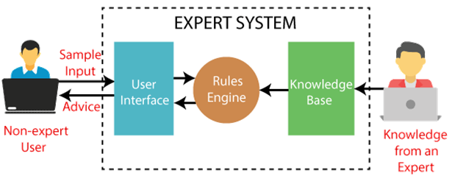

### Components

Rule-based systems consist of several key components that work in concert to enable their functionality:

1. **Knowledge Base:** At the heart of the system is the knowledge base, a repository of domain-specific facts and rules. This database captures the expertise that the system relies on to make decisions.
2. **Inference Engine:** The inference engine is the powerhouse of the system, applying the rules from the knowledge base to known facts. It deduces new facts and makes logical inferences based on the input it receives.
3. **User Interface:** Rule-based systems often include a user interface that facilitates interactions with users. This interface can take various forms, ranging from simple text-based interfaces to more sophisticated graphical representations.

### Applications

Rule-based systems find applications in a myriad of domains, each benefiting from the explicit encoding of knowledge into rules. Some notable applications include:

1. **Medical Diagnosis:** In healthcare, rule-based systems excel at diagnostic tasks. They can use a set of rules based on symptoms, patient history, and medical knowledge to assist in the identification of diseases or conditions.
2. **Financial Systems:** Rule-based systems play a crucial role in financial applications, where predefined rules can govern transactions, risk assessments, and compliance checks.
3. **Game AI:** In certain gaming scenarios, rule-based systems are employed to create non-player characters (NPCs) that exhibit specific behaviors. The rules govern how these characters respond to different in-game situations.

### Advantages:

1. **Transparency:** The explicit nature of rules makes these systems highly transparent. Users and developers can understand the decision-making process by examining the rules and the knowledge base, fostering trust in the system.
2. **Ease of Update:** Modifying or updating a rule-based system is relatively straightforward. When there are changes in the domain knowledge or rules need refinement, updates can be made directly to the knowledge base without requiring extensive retraining.

### Disadvantages

1. **Lack of Learning:** Rule-based systems operate based on predefined rules and do not inherently learn from data. This lack of adaptability can be a drawback in dynamic environments where patterns evolve over time.
2. **Potential Unwieldiness:** As the number of rules increases, managing and maintaining rule-based systems can become complex. The sheer volume of rules may lead to intricacies that are challenging to navigate and update.

In-Class Activity:

* Think of an application that has traditionally been an expert system. Think of how that application has already or can be transformed by Deep Learning. Go on the discussion board and post your application, explain how it is/was an expert system, and how Deep Learning has or can change it.
  + E.g., Spellcheck on a computer used to be rule oriented and most systems now use AI to accomplish this.

### The Evolution of Rule-based Systems: From Deterministic Logic to Hybrid Approaches

In recent years, the landscape of rule-based systems has witnessed evolution. Hybrid approaches, combining rule-based reasoning with machine learning techniques, aim to overcome some of the limitations inherent in traditional rule-based systems. By incorporating learning mechanisms, these hybrid systems can adapt to changing patterns in data while still leveraging the transparency and interpretability of rule-based logic.

## Chapter 2 - Navigating the Divide: Traditional Software Development vs. AI Systems

In the ever-evolving landscape of technology, the duality between traditional software development and the burgeoning field of artificial intelligence (AI) systems represents a significant paradigm shift. While both serve the common goal of empowering computers to perform tasks, the approaches, characteristics, and implications differ substantially. This exploration delves into the nuanced distinctions between traditional software development and AI systems, unpacking their deterministic nature, the dichotomy of programming versus training, the complexity they handle, and the maintenance dynamics that govern their life cycles.

### Deterministic Nature: The Certainty of Traditional Software

At the heart of the divergence lies the deterministic nature of traditional software. In traditional development, the behavior of software is entirely predictable – a function of its explicit programming. If provided with a specific input, traditional software will consistently produce the same output, adhering to the predefined logic and rules set by the programmer. This predictability is a fundamental characteristic that has long been the cornerstone of software engineering.

Contrastingly, AI systems introduce an element of probabilistic uncertainty. Their responses are not rigidly predetermined by programmed instructions but are influenced by the patterns and correlations discerned during training. The deterministic predictability of traditional software stands in stark contrast to the adaptive and learning-centric nature of AI systems.

### Programming vs. Training: The Essence of Instruction

A pivotal distinction arises in how these systems acquire intelligence. Traditional software relies on explicit programming, where developers meticulously craft the logic and rules that govern the system's behavior. The rules are clearly defined, leaving no room for interpretation. This deterministic approach provides clarity and precision but may falter when faced with tasks that are inherently complex or lack well-defined rules.

In contrast, AI systems, particularly machine learning models, eschew explicit programming in favor of training. Instead of instructing the system with explicit rules, developers expose it to vast datasets, allowing it to discern patterns and relationships autonomously. The system learns from the data, adjusting its internal parameters to optimize its performance. This shift from explicit programming to learning introduces an adaptive quality, enabling AI systems to tackle tasks that may be too intricate for rule-based programming.

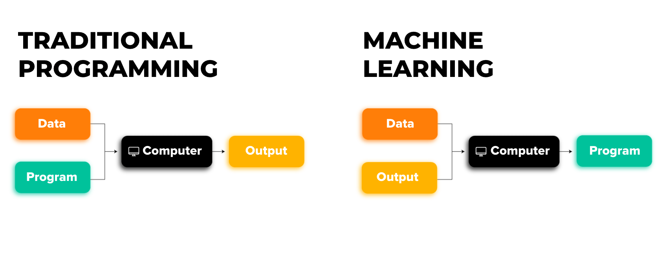

### Complexity: From Explicit Rules to Cognitive Challenges

The terrain of complexity is where the chasm between traditional software and AI systems widens. Traditional software excels in tasks with well-defined rules and clear logic. However, when confronted with tasks that involve nuanced decision-making, pattern recognition, or understanding unstructured data, traditional software often falters.

AI systems, on the other hand, thrive in the realm of complexity. Tasks that are challenging to articulate through explicit rules, such as recognizing objects in images, understanding human speech, or translating languages, become feasible for AI models. The ability of AI systems to navigate intricate scenarios and discern non-linear patterns positions them as powerful tools for tasks that elude the deterministic grasp of traditional software.

### Other Considerations:

### Maintenance: Evolving Dynamics in the Lifecycle

### The Interplay and Future Synergy: Embracing Both Realms

## Chapter 3 - Navigating the Essence of AI and Non-AI Approaches

In the ever-evolving landscape of technology, the role and significance of data form a nexus around which the realms of artificial intelligence (AI) and non-AI approaches orbit. This exploration delves into the multifaceted importance of data, unraveling the intricate dance between AI, which thrives on data-driven paradigms, and non-AI approaches that navigate the terrain of explicit logic. Beyond the dichotomy, a compelling narrative emerges as these approaches coalesce, giving rise to hybrid solutions that leverage the strengths of both data-centric AI and logic-driven non-AI methodologies.

### Data-Driven Dynamics of AI: A Symphony of Information

At the heart of AI's prowess lies its insatiable appetite for data. Particularly within machine learning models, the trajectory of performance is intricately tied to the quantity, quality, and relevance of the training data. AI systems are, in essence, sophisticated learners, extracting patterns, correlations, and insights from the vast data landscapes they traverse.

The data-driven nature of AI unveils a symphony of information. Machine learning models, whether engaging in supervised learning, unsupervised learning, or reinforcement learning, rely on historical data to discern trends, make predictions, or optimize decision-making processes. The more diverse and representative the data, the more robust and adaptable the AI model becomes. From image recognition to natural language processing, the effectiveness of AI is deeply entwined with the richness of the data it encounters.

### Explicit Logic in Non-AI: A Dance of Prescribed Precision

In stark contrast, non-AI approaches carve their path through explicitly defined logic. These systems, often rule-based or deterministic, function based on predefined rules, conditions, and algorithms. Unlike their data-hungry AI counterparts, non-AI methodologies find their strength in the clarity and precision of explicit instructions.

In traditional software development and rule-based systems, the logic is meticulously programmed, leaving little room for ambiguity. These systems operate in a deterministic realm, where given a specific input, the output is entirely predictable. The absence of a reliance on data-driven patterns distinguishes non-AI approaches, making them well-suited for tasks with clearly defined rules and straightforward decision-making processes.

### Combining Forces: The Emergence of Hybrid Approaches

The narrative transcends a mere dichotomy as the convergence of AI and non-AI approaches unveils the prospect of hybrid solutions. In many real-world applications, a symbiotic relationship is forged where AI processes data and makes initial decisions, which are subsequently refined and processed by rule-based logic for final decisions.

Consider a scenario in fraud detection within financial systems. AI models can analyze vast datasets, identifying potential anomalies and patterns indicative of fraudulent activity. However, to make the final decision, explicit rules and logic are applied, incorporating regulatory requirements, risk thresholds, and specific business rules. This amalgamation of data-driven insights and rule-based logic encapsulates the strengths of both paradigms, offering a comprehensive and adaptive solution.

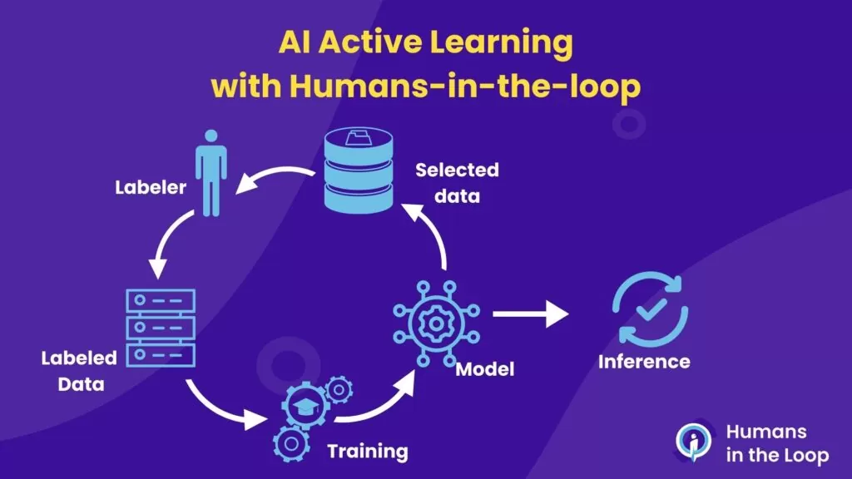

### Other Considerations:

### The Interplay in Specific Domains: Tailoring Approaches to Context

### Challenges and Opportunities: The Dual-Edged Sword of Data Dependence

### Looking to the Future: Synergies and Ethical Considerations

Read through the following: <https://dataconomy.com/2022/06/28/meaning-of-ai-and-ml/>

## Chapter 4 - Navigating the Frontiers

In the intricate dance between technology and human ingenuity, the limitations of non-AI approaches emerge as signposts, marking the boundaries of what can be achieved through explicit logic and rule-based systems. As we delve into the nuances of these limitations, a tapestry unfolds, weaving together scalability challenges, adaptability constraints, the intricacies of complex tasks, and the resource intensity inherent in traditional systems. In traversing this terrain, we gain insights into why the allure of artificial intelligence (AI) beckons, offering solutions that transcend the constraints faced by non-AI methodologies.

### Scalability: The Quandary of Complexity

One of the primary limitations that non-AI approaches grapple with in modern applications is scalability. As tasks become more intricate, involving a myriad of variables and conditions, encoding explicit rules can swiftly become impractical. Rule-based systems, by their nature, demand manual articulation of rules and conditions for every conceivable scenario. This process is not only time-consuming but also prone to oversight, especially in domains where the complexity of the task surpasses the human capacity to anticipate every nuance.

Consider a scenario in finance, where rule-based systems are often employed for decision-making in fraud detection. As the financial landscape evolves and fraudsters adopt new tactics, the rule set must be continuously expanded and refined. In such dynamic environments, the scalability of rule-based systems falters. AI, on the other hand, exhibits a natural proclivity for scalability. Machine learning models, given sufficient data, can autonomously learn and adapt to evolving patterns, overcoming the scalability limitations inherent in explicit rule encoding.

### Adaptability: The Static Nature of Traditional Systems

Adaptability stands as another cornerstone where non-AI approaches reveal their limitations. Traditional systems, once deployed, operate in a static state until manually updated. This lack of adaptability to new data or changes in the environment can be a critical shortcoming, particularly in domains where real-time responsiveness is paramount.

Consider a manufacturing process governed by rule-based systems to ensure quality control. If a new material or manufacturing technique is introduced, the rules governing quality parameters may become outdated. Updating these rules manually can be a cumbersome and error-prone process. In contrast, AI systems can be retrained with new data, enabling them to adapt seamlessly to changes. This adaptability becomes increasingly crucial in dynamic environments where constant evolution is the norm.

### Complex Tasks: Where Explicit Programming Hits its Limits

The intricate dance of non-AI approaches falters when confronted with tasks characterized by complexity, ambiguity, and a multitude of variables. Natural language processing, image recognition, and applications involving extensive data processing exemplify scenarios where explicit programming struggles to keep pace.

Take, for instance, natural language processing tasks like sentiment analysis in social media data. The nuances of human language, context, and evolving expressions make it challenging to encode explicit rules that comprehensively capture the intricacies of sentiment. In image recognition, the sheer diversity of visual patterns and the vast array of potential inputs make it impractical to rely solely on predefined rules. AI, with its ability to discern complex patterns from data, excels in handling tasks that transcend the boundaries of explicit programming.

### Resource Intensity: Balancing Efficiency and Complexity

While rule-based systems can be efficient for specific tasks, their efficiency may diminish as the number of rules and exceptions grows. Resource intensity becomes a pertinent concern, especially when dealing with expansive datasets and multifaceted applications.

Consider a logistics system where rule-based algorithms govern the routing of delivery vehicles. As the system incorporates more rules to optimize routes based on factors like traffic conditions, delivery priorities, and vehicle capacities, the computational load escalates. The need to process an increasing number of rules and exceptions may lead to diminishing efficiency and slower decision-making. In contrast, AI models, once trained, can efficiently process vast amounts of data, adapting to complex decision-making scenarios without succumbing to resource-intensive bottlenecks.

### The Evolving Landscape: Why AI Beckons

As we navigate the limitations of non-AI approaches, the allure of AI becomes evident. The ability of AI to scale seamlessly, adapt to new data, tackle complex tasks, and balance efficiency in the face of increasing complexity positions it as a compelling alternative.

In scalable AI applications, the burden of manually crafting rules diminishes, allowing systems to evolve with minimal human intervention. Adaptability to changing environments and dynamic datasets ensures that AI systems remain relevant and effective over time. The prowess of AI in handling complex tasks involving intricate patterns, such as natural language processing or image recognition, demonstrates its versatility. Moreover, the efficiency with which AI processes vast datasets speaks to its ability to navigate resource-intensive scenarios with finesse.

### Striking a Balance: The Synergy of AI and Non-AI

While the limitations of non-AI approaches are apparent, it's essential to recognize that these methodologies have their strengths, particularly in well-defined, deterministic tasks. Striking a balance between the precision of explicit logic and the adaptive capabilities of AI becomes a strategic imperative.

In hybrid solutions, AI can be employed to process vast datasets and make initial decisions, which are then refined and governed by rule-based logic. This symbiotic relationship leverages the strengths of both paradigms, offering a nuanced approach that transcends the limitations of individual methodologies.

### Challenges of Responsible AI: A Call for Ethical Considerations

As we embrace the potential of AI, ethical considerations come to the forefront. Responsible AI practices become imperative to ensure that the advantages gained through data-driven adaptability do not come at the cost of perpetuating biases, compromising privacy, or entrenching societal inequities. The responsible use of AI involves transparency, fairness, and ongoing monitoring to address ethical concerns.

## In-Class Activity:

Objective: Investigate traditional software that was ahead of its time. Try to ideate whether these applications were AI-based or non-AI.

#### Activity Structure:

* In groups of 3, read through the following article: <https://www.vice.com/en/article/jpgpey/a-history-of-smarterchild> and discuss your thoughts with your teammates.
* Try to solve how they were able to achieve such a feat before AI was widespread.
* Investigate other applications, past or present, that may be using AI or non-AI approaches. As a group, formulate some opinions on types of applications that should continue to stay as non-AI based applications.

## Conclusion:

Week 7 delved into the intricate dynamics of rule-based systems, emphasizing their transparent decision-making but grappling with challenges in scalability and adaptability. The exploration underscored the deterministic nature of traditional software, contrasting it with the learning-centric approach of AI. Traditional software's predictability in well-structured tasks was contrasted with AI's ability to handle complex, dynamic scenarios by learning from vast datasets.

Furthermore, the discussion shed light on the crucial role of data in AI, emphasizing its data-driven nature. In contrast, non-AI approaches rely on explicit logic, showcasing strength in well-defined tasks. The narrative explored hybrid solutions, illustrating scenarios where AI processes data for initial decisions, refined by rule-based logic. Challenges in responsible AI practices were highlighted, emphasizing the need for transparency and fairness. The limitations of non-AI approaches, particularly in handling nuanced tasks, were elucidated, leading to a strategic call for balancing explicit logic and AI adaptability. The future vision involves a collaborative synergy between both paradigms, leveraging their respective strengths for a harmonious integration in technological advancements.